Satan’s X-ray Vision Into Our Faults
August 19, 2017
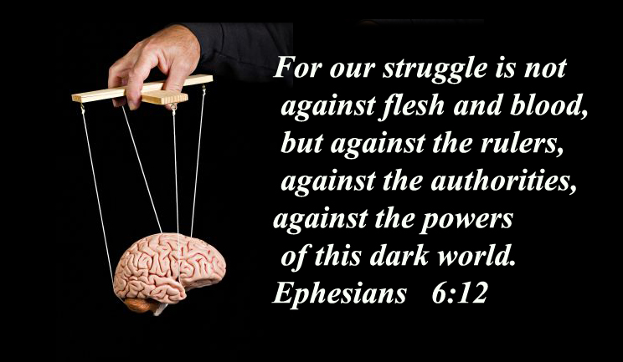
Lord, I ask that Your gentle hand would lead us into great depths in discovering ourselves and at the same time shower us with Your love and encouragement. Amen

Lord, thank you for the encouragement. How beautiful it was during my communion service, during the sign of peace—several saints from the great cloud of witnesses rushed to encircle me and encourage me not to despair. I have still not been able to devote myself to music as I have wanted to.

We had an internal situation that called for much prayer, writing, and resolution. The enemy has been trying to divide the prayer warriors on this channel for over a year now. They wouldn’t be doing that if the prayer warriors weren’t powerful and making great headway in the Kingdom of God on Earth.

It is mostly the innocent souls that suffer from these attacks and the enemy has X-ray vision into the weaknesses of others. He knows precisely how to play them to cause factions and division. Dear Heartdwellers, it is not so much certain people who cause church splits, it is the enemy using those who are not aware of how they are being used.

We must also have X-ray vision when dealing with people. We must be able to see and determine how certain personalities will affect our work. It is a great gift to have volunteers, yet it is also a great responsibility. So, I have been working with these situations for three days now and it seems that we have reached a place of relative peace and understanding, and closed the door on what Satan wanted to accomplish.

This is the second attempt the enemy has made to cause division in loyalties, and I thank the Lord He has not succeeded. Rather we are closer than ever and learning everyday about his tactics. And I’ll share with you everything the Lord shows me.

Lord, have you anything to say?

“Yes, Beloved, I do. I want you all to understand that each of you has weaknesses. Even if you are deeply devoted to Me, there is still the flesh and Satan will play you like a puppet if you do not know yourself. Please, bear with Me. I know I have spoken of this before, but you are your own worst enemy and to know Me and yourself are the top priorities if you want to overcome the enemy in your life.

“It is true that Satan does have X-ray vision into your personalities. He also has files. The kingdom of darkness is highly organized. They can examine your life and tell in a heartbeat where to set you up for a fall. Two things are necessary: Pride and blindness to your faults. Without pride, you will not listen to the enemy and do things that can hurt the cause of an organization you are with. You must have an attitude of self-righteousness, and a sense of being right in your walk with Me.

“A soul that does not recognize how vulnerable they are is a very dangerous soul. To not know your failed dreams, frustrations and tendencies is to be blind to the tactics of the enemy, who has the ability, by virtue of this information, to steer you right into trouble for yourself and trouble for others.

“With a sense of pride and the attitude of being secure in your relationship with Me, and always being right, always having answers—even when it goes against the teachings of the leader of a group you are working with—is a wide open door for the enemy to cause division.

“My children, this Earth is like a big sandbox, and sometimes in your immaturity you throw sand at one another. It seems like nothing. But beneath the sand, deadly snakes are biding their time until they can inject you and the others with the venom of pride, rebellion, self-righteousness leading to judgment and wanting to be an authority figure and change things to your own thinking.

“My leaders may not be anything to look at, but they have one thing going for them: they don’t trust themselves. They know they are not righteous, they know they are proud and open to error and therefore they cleave to Me in all their ways. That is why I put them there. They know they could fall in a heartbeat and the last thing they want to do is fail Me.

“Others who do not see their faults that clearly and have strong opinions and a drive to dominate, are the perfect set-up for the enemy. That is why I am training each of you in humility and to hate self-reliance and see it for what it is: a deadly trap. Yes, My leaders make mistakes, very human mistakes, but it is your job to back them up in prayer so they don’t go far after they’ve done something not pleasing to Me.

“These dynamics are not just for groups with a leader. These dynamics are for discerning your lives, making your marriages healthy, raising children, seeking a life path. If you are convinced you know best, you will most probably fail. I say most probably because there are those times when you have sought me over time and have a strong LEADING to pursue a certain direction. Those attitudes don’t count, because you have sought Me for so long.

“I am talking about people who make life decisions based on what they think is best, whether it be security in a career, the choice to be insecure and follow Me into the mission field. You still need to yield to My wisdom, lest you make a seriously wrong life decision. There is no person harder to direct on this Earth than the soul who is convinced they are right.

“How can that be, you ask? Very simply, a self-reliant soul will not agonize with Me over what direction they should take. Rather, they feel qualified and confident they’ve made the right choice. A wise soul will at times fall into doubts and fears that they are choosing for themselves and not what I would have them do. Yes, they doubt. Yes, they fear—and that’s what brings them back to Me to re-discern and be absolutely positive I am leading them and they are not leading themselves into a trap for their lives. These souls I can work with.

“The others? Well, it is sad to say but I let them sleep in the bed they made for themselves until they come to Me broken and say, ‘What happened? I was so sure I was right.’ By then, time has been wasted, resources wasted, and the soul is ashamed that they didn’t seek Me to begin with, rather they second guessed Me based on human reasoning and galloped off into their own direction. They resisted Me when I counselled them. But at least now, they have a second chance.

“Of course, the worst and most tragic souls are the ones that don’t see they never sought Me, so they blame the world on their failures and again with the bit in their mouths go off on another wrong direction. At the end of their lives, they are filled with bitterness because everything they tried failed them and their lives are unfulfilled. How tragic. Please do not let this happen to you. Please seek Me until you find Me. And remember: I am not an easy catch.

“Some of you are still questioning, ’What am I to do??’ You still haven’t found your place. Continue to seek Me. Spend more time repenting and seeing the sins in your lives, spend more time laying your life before Me and asking Me to take it up and make it beautiful—as it should be. I will NEVER turn down a soul who seeks me in this fashion. You have to go all the way in your discernment of yourself; you have to be willing to open those closet doors where the skeletons are stored. You have to deeply forgive and know that your choices are what led to your failures, not other people. In short, you have to take responsibility for your mistakes.

“There is no one more teachable than the soul who comes to Me saying—from the heart, with conviction, ‘Lord, I have gone my own way and failed. I’ve made a mess of my life. I don’t have a clue! All I can do is throw myself on Your mercy and cry, “Lord take my life and make it beautiful for You!” This is an empty vessel and with this I can do marvelous things.

“So you see, My People, you have nothing to fear in learning who you are and who you aren’t. In fact, you have everything to gain, because you are digging deep down to the bedrock of truth and on this I can lay a foundation. It is those with a self-inflated opinion of themselves that are in deep trouble and go from one situation to another causing disorder and failing.

“Turn off the TV, turn off the computer, turn off the noise in the house. Get a quiet corner and seek Me until I come to you. Be gut-honest about who you really are and who you really are NOT. You have nothing to lose. Certainly not My love.”

